Planning & Development
208 Sanford Road, Wells, Maine 04090
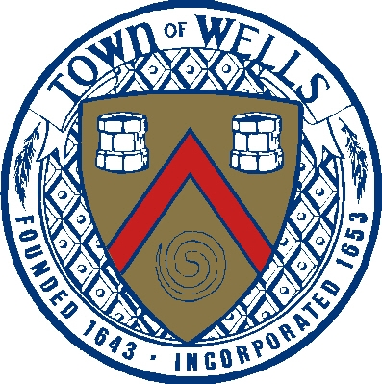
Phone: (207) 646-5187, Fax: (207) 646-7046
Website: www.wellstown.org

Michael G. Livingston, Town Engineer/Planner | mlivingston@wellstown.org
Shannon L.M.. Belanger, Assistant Planner | sbelanger@wellstown.org

Memo

Date: August 10, 2022

To: Planning Board

From: Michael G. Livingston, Town Engineer/Planner

Re: Nonconforming Mobile Home Parks

Background:
A property owner of a grandfathered mobile home park brought attention to the Planning Office that a potential conflict between State Statute, M.R.S.A. 30-A § 4358, and the Town Ordinance. The law sets restrictions on density that a municipality can require for a Mobile Home Park. The Town ordinances address new Parks and existing Park expansions, but does not address the lot size requirement for an existing grandfathered Park.

The Board of Selectmen held a workshop on their August 2nd meeting and had a consensus that the changes were a good proposal and should be forwarded to the Planning Board for consideration.

Current Ordinances:
Current ordinances and definitions would require the same density as the District in which the Park is located and the Park to be considered a multifamily development.

Impacts:
Only three such Parks exist. The other two already exceed 20,000 sf per unit and could not reduce their lot size.

Ordinance Changes:
The ordinance changes are Land Use ordinances that require adoption at Town Meeting by the voters. See attached proposed changes and copy of the State statute. The ordinance change would not apply if the Park is subject to a previous approved plan.

Considerations:

- The Planning Board should consider if any revisions to the proposed changes are recommended.

- The Planning Board should consider scheduling a public hearing for the September 12, 2022 meeting which could be a joint meeting with the Board of Selectmen if the change is to be placed on the November ballot.

