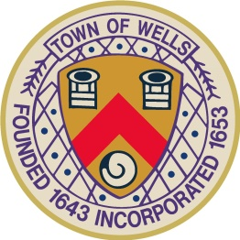
TOWN OF WELLS
Wells, Maine
pamC
COMMITTEE FOR VETERANS’ AFFAIRS
AGENDA
Tuesday, March 10, 2026
5:00 PM, Littlefield Meeting Room

- Pledge of Allegiance

- Call to Order and Determination of Quorum / Attendance

- Review and Approval of Meeting Minutes

- New Business:
  - Memorial Day Parade planning
    - Incorporating our nation’s 250th birthday celebration
  - Anchor Real Estate’s offer to sponsor a veteran meal
    - Wells/Ogunquit senior center lunch/dinner?
    - Lunch or dinner week before Memorial Day?
  - Blue Star Memorial Plaque offered by the Seacoast Garden Club

- Old Business:
  - Veterans Monument and rededication subcommittee update

- Other Business:

- Open to the Public

- Adjournment

