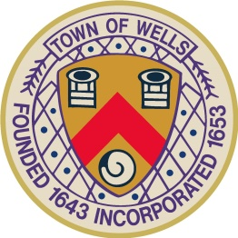
TOWN OF WELLS
Wells, Maine
pamC
COMMITTEE FOR VETERANS’ AFFAIRS
AGENDA
Tuesday, February 10, 2026
5:00 PM, Littlefield Meeting Room

- Pledge of Allegiance

- Call to Order and Determination of Quorum / Attendance

- Review and Approval of Meeting Minutes

- New Business:
  - Memorial Day Parade planning
    - Incorporating our nation’s 250th birthday celebration
      - utilization of military uniforms by Wells high schoolers coordination
    - Enhanced section in March town newsletter soliciting parade participation
  - Roundtable with town veterans February 13 from 9:30 AM to 11 AM
    - program agenda

- Old Business:
  - Veterans Monument and rededication subcommittee update

- Other Business:

- Open to the Public

- Adjournment

