Code Enforcement and Planning & Development
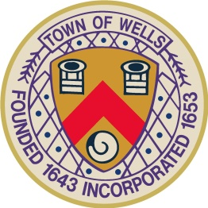

208 Sanford Road, Wells, Maine 04090
Phone: (207) 646-5187, Fax: (207) 646-7046
Website: www.wellstown.org

Wells Lodging Facility Advisory Committee Meeting
Wednesday February 12, 2025, 1:00 P.M.
Wells Town Hall Meeting Room
208 Sanford Road

1:00 P.M. CALL MEETING TO ORDER & DETERMINATIONS OF QUORUM

- OPEN TO THE PUBLIC

- APPROVAL OF MINUTES

- REVIEW PROPOSED ORDINANCE CHANGES FOR CHAPTER 150 LICENSES AND PERMITS

- OPEN TO THE PUBLIC

- ADJOURNMENT

